CS202 Assignment 1 – Shin Minchul
Q1. Study of Choose.java
This given Java program works similar to Combination in Mathematics, where$n$ stands for total number of objects in the set,$r$ stands for the number of chosen objects from the set. The program prints all possible subsets of size r from an array e of n elements. The method “choose (int b, int c)” generates recursion to recurse all possible selection of r elements from the given n elements that is inputted by the user.
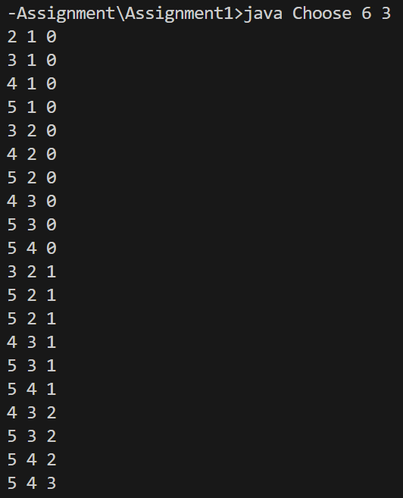
Figure 2. Example output of Choose.java
As the key implementation of the program is related to choosing method, I will further explain about it. The method looks like working as follows:
- It selects r elements from n.
- If c < 0, it prints the selected subset ‘a’ array.
- Else, it iterates over possible selection from i = b to i < n – c.
- Each selection in each recursive level will be stored in array a, and recursive call is made for the next element.
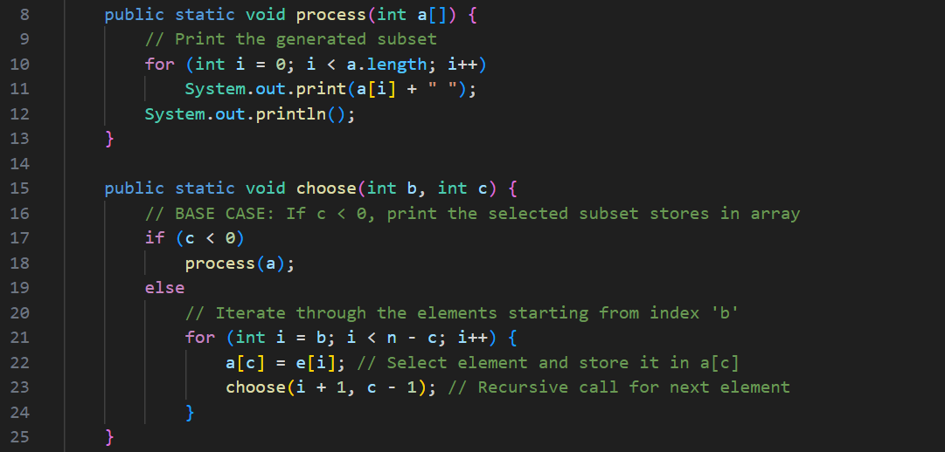
Figure 3. Comments and explanation of what the function does

*Just in case it is blurred, the image is saved in pdf file inside the folder
Q3. Asymptotic Analysis

3.1 Part 1
Using the Master Theorem, we now calculate Asymptotic bound for the recurrence:
$$T\left(n\right)=12∙T\left(\frac{n}{4}\right)+n^{2}$$
First, we should get a, b and f(n) to apply for the Master Theorem which are the following:
$$a = 12, b = 4, and f(n) =n^{2}$$
From here, calculate $\log_{b}{a}=\frac{\log\left(12\right)}{\log\left(4\right)}≈1.792$ and compare $n^{\log_{b}{(a)}}=n^{1.792}$ with $f\left(n\right)=n^{2}$.
As $n^{2} >n^{1.792}$, f(n) grows faster. Thus, Case 3 may be applied. Let’s verify the Regularity Condition, it must hold:
$12 f\left(\frac{n}{4}\right)≤c∙f\left(n\right) for some c < 1, and sufficiently large n$
$12 f\left(\frac{n}{4}\right)=12 {\left(\frac{n}{4}\right)}^{2}=12∙\frac{n^{2}}{16}=\frac{12}{16}n^{2}=\frac{3}{4}n^{2} (LHS)$
$\frac{3}{4}n^{2}≤cn^{2}$
The equation satisfied for some c < 1 such as 0.5 hence, case 3 applied to conclude: $T(n) =Θ\left(n^{2}\right)$

3.2 Part 2
Using the Master Theorem, we now calculate Asymptotic bound for the recurrence:
$$T\left(n\right)=3∙T\left(\frac{n}{3}\right)+n\log{n}$$
$$a = 3, b = 3, and f\left(n\right)=n\log{n}$$
From here, calculate $\log_{b}{a}=\frac{\log\left(3\right)}{\log\left(3\right)}=1$ and compare $n^{\log_{b}{(a)}}=n^{1}$ with $f\left(n\right)=n\log{n}$. Even though the n log n grows slightly faster than $n^{1}$, to apply case 3 it must hold $f(n) = Ω(n^{1+ε})$. So, following equation should hold:
$$n log n{=Ω(n^{1+ε}) }$$
However, for any small $ε>0$, we see $n log n{=o(n^{1.1})}$. Hence, $n log n$ grows slower than $n^{1+ε}$, thus instead of case 3, check whether it is form of case 2 condition: $Θ(n^{\log_{b}a}∙\log^{k}{n})$. Here it satisfies the condition 2,
and f(n) = n log n and k = 1 hence,
$$T(n)=Θ(n\log^{2}{n})$$

- END OF THE ANSWER -

